25. Plot Two or More Lines with Legends, Different Widths and Colors
import matplotlib.pyplot as plt
x = [1, 2, 3, 4, 5]
y1 = [2, 4, 6, 8, 10]
y2 = [1, 3, 5, 7, 9]
y3 = [5, 6, 7, 8, 9]
plt.plot(x, y1, color='red', linewidth=2, label='Line 1')
plt.plot(x, y2, color='blue', linewidth=3, label='Line 2')
plt.plot(x, y3, color='green', linewidth=1, label='Line 3')
plt.xlabel("X Axis")
plt.ylabel("Y Axis")
plt.title("Multiple Line Chart")
plt.legend()
plt.show()
OUTPUT:
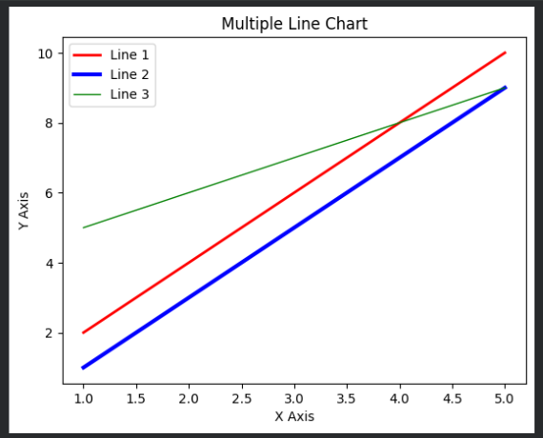

26. Create Multiple Plots
import matplotlib.pyplot as plt
x = [1, 2, 3, 4, 5]
y = [2, 4, 6, 8, 10]
plt.subplot(2, 2, 1)
plt.plot(x, y)
plt.title("Line Plot")
plt.subplot(2, 2, 2)
plt.bar(x, y)
plt.title("Bar Plot")
plt.subplot(2, 2, 3)
plt.scatter(x, y)
plt.title("Scatter Plot")
plt.subplot(2, 2, 4)
plt.plot(x, y, marker='o')
plt.title("Line with Markers")
plt.tight_layout()
plt.show()
OUTPUT:
